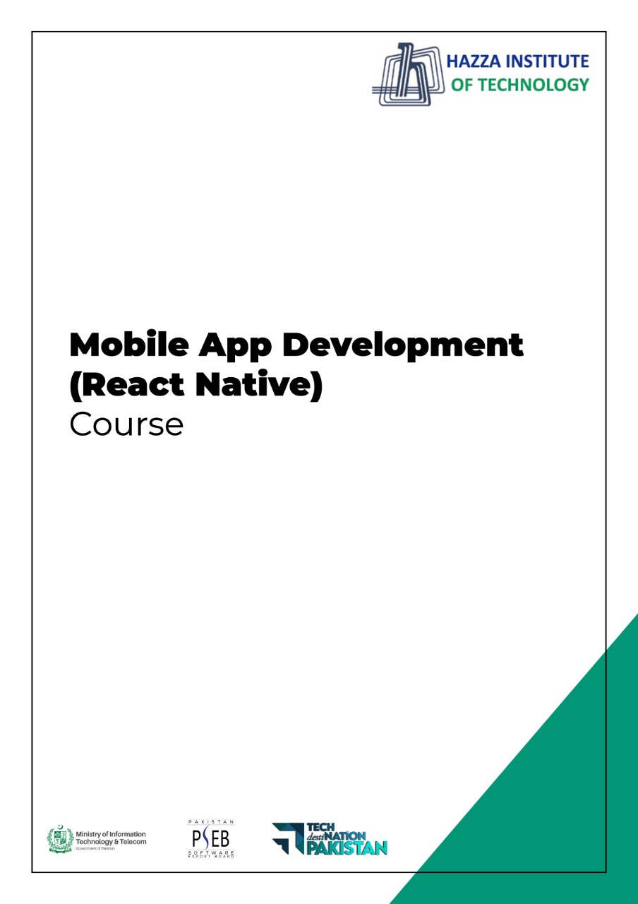

**(Flutter)**

Flutter Lab 6 (Session 2)

**Total Time:**

**3 hours (sessions-1)**

**Pre-Lab Activities:**

* + Student Must have Knowledge about Widget dart function.

**Learning Outcomes:**

* + Students will learn about external libraries
  + Students will learn the use of functions in Flutter
  + Students will learn more about layout widgets

**Lab Task- 2:**

In Lab Task 1, Expanded widgets are repeated seven times. Enclose Expended widgets in a function and call the this function seven time instead 7 Expanded block.

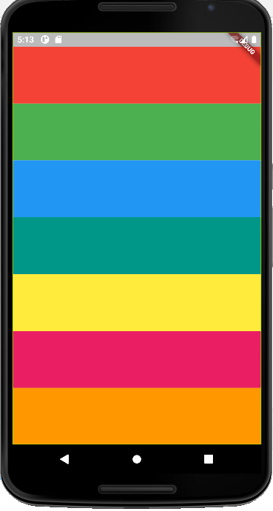Create another function for sound and pass sound value to this function from onPressed callback function.

**Lab Solutions:**

**LAB 6.2 :**

|  |
| --- |
| import 'package:flutter/material.dart';  import 'package:audioplayers/audioplayers.dart';  void main() => runApp(MaterialApp(  home: xylophone(),  ));  class xylophone extends StatelessWidget {  const xylophone({Key? key}) : super(key: key);  void soundPlayer(int note){ final player = AudioCache();  player.play('note$note.wav');}  Expanded xylophonefun({required Color color, required int soundPlay}){  return Expanded(  child: TextButton(  style: ButtonStyle(backgroundColor: MaterialStateProperty.all(color)),  onPressed: () { soundPlayer(soundPlay);  },  child: Text("Press Me"),  ),  );  }  @override  Widget build(BuildContext context) {  return Scaffold(  backgroundColor: Colors.black,  appBar: AppBar(title: Text('Xylophone'),  ),  body: SafeArea(  child: Container(  child: Column(  crossAxisAlignment: CrossAxisAlignment.stretch,  children: [  xylophonefun(color: Colors.orange, soundPlay: 1),  xylophonefun(color: Colors.yellow, soundPlay: 2),  xylophonefun(color: Colors.pink, soundPlay: 3),  xylophonefun(color: Colors.purple, soundPlay: 4),  xylophonefun(color: Colors.indigo, soundPlay: 5),  xylophonefun(color: Colors.red, soundPlay: 6),  xylophonefun(color: Colors.brown, soundPlay: 7),  ],  ),),  ),  );  }  } |